**Ex no 5: Implementation of Pi calculation and Matrix multiplication using Point to Point communication**

* **Pi calculation**

#include <stdio.h>

#include <stdlib.h>

#include <time.h>

#include <mpi.h>

int main(int argc, char** argv) {

MPI_Init(&argc, &argv);

int rank, size;

MPI_Comm_rank(MPI_COMM_WORLD, &rank);

MPI_Comm_size(MPI_COMM_WORLD, &size);

// Number of total random points

int total_points = 1000000;

// Points inside the quarter-circle

int points_inside = 0;

// Initialize random seed based on process rank

srand(time(NULL) + rank);

// Generate random points and count those inside the quarter-circle

for (int i = 0; i < total_points; ++i) {

double x = (double)rand() / RAND_MAX;

double y = (double)rand() / RAND_MAX;

if (x * x + y * y <= 1.0) {

points_inside++;

}}

// Sum up points_inside across all processes using MPI_Reduce

int global_points_inside;

MPI_Reduce(&points_inside, &global_points_inside, 1, MPI_INT, MPI_SUM, 0, MPI_COMM_WORLD);

// Only the master process (rank 0) performs the final calculation and prints the result

if (rank == 0) {

double pi_estimate = 4.0 * global_points_inside / (double)(total_points * size);

printf("Estimated value of pi: %lf\n", pi_estimate);

}

MPI_Finalize();

return 0;}

**Output:**

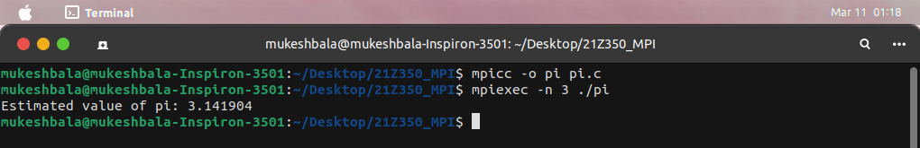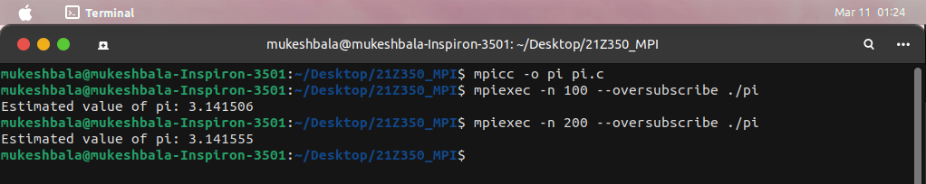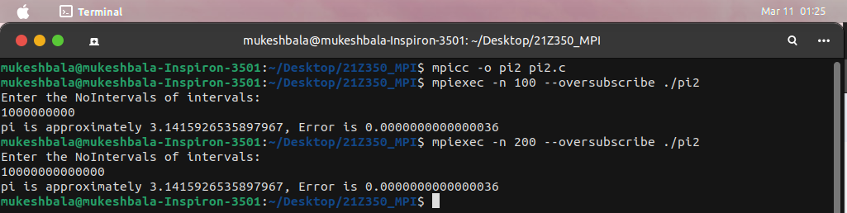

* **Matrix Multiplication**

#include <stdlib.h>

#include <stdio.h>

#include "mpi.h"

#include <time.h>

#include <sys/time.h>

// Number of rows and columnns in a matrix

#define N 4

MPI_Status status;

// Matrix holders are created

double matrix_a[N][N],matrix_b[N][N],matrix_c[N][N];

int main(int argc, char **argv)

{

int processCount, processId, slaveTaskCount, source, dest, rows, offset;

struct timeval start, stop;

MPI_Init(&argc, &argv);

MPI_Comm_rank(MPI_COMM_WORLD, &processId);

MPI_Comm_size(MPI_COMM_WORLD, &processCount);

slaveTaskCount = processCount - 1;

if (processId == 0) {

srand ( time(NULL) );

for (int i = 0; i<N; i++) {

for (int j = 0; j<N; j++) {

matrix_a[i][j]= rand()%10;

matrix_b[i][j]= rand()%10;

}

}

printf("\n\t\tMatrix - Matrix Multiplication using MPI\n");

printf("\nMatrix A\n\n");

for (int i = 0; i<N; i++) {

for (int j = 0; j<N; j++) {

printf("%.0f\t", matrix_a[i][j]);

}

printf("\n");

}

printf("\nMatrix B\n\n");

for (int i = 0; i<N; i++) {

for (int j = 0; j<N; j++) {

printf("%.0f\t", matrix_b[i][j]);

}

printf("\n");

}

rows = N/slaveTaskCount;

offset = 0;

for (dest=1; dest <= slaveTaskCount; dest++)

{

MPI_Send(&offset, 1, MPI_INT, dest, 1, MPI_COMM_WORLD);

MPI_Send(&rows, 1, MPI_INT, dest, 1, MPI_COMM_WORLD);

MPI_Send(&matrix_a[offset][0], rows*N, MPI_DOUBLE,dest,1, MPI_COMM_WORLD);

// Matrix B is sent

MPI_Send(&matrix_b, N*N, MPI_DOUBLE, dest, 1, MPI_COMM_WORLD);

// Offset is modified according to number of rows sent to each process

offset = offset + rows;

}

// Root process waits untill the each slave proces sent their calculated result with message tag 2

for (int i = 1; i <= slaveTaskCount; i++)

{

source = i;

// Receive the offset of particular slave process

MPI_Recv(&offset, 1, MPI_INT, source, 2, MPI_COMM_WORLD, &status);

// Receive the number of rows that each slave process processed

MPI_Recv(&rows, 1, MPI_INT, source, 2, MPI_COMM_WORLD, &status);

// Calculated rows of the each process will be stored int Matrix C according to their offset and

// the processed number of rows

MPI_Recv(&matrix_c[offset][0], rows*N, MPI_DOUBLE, source, 2, MPI_COMM_WORLD, &status);

}

// Print the result matrix

printf("\nResult Matrix C = Matrix A * Matrix B:\n\n");

for (int i = 0; i<N; i++) {

for (int j = 0; j<N; j++)

printf("%.0f\t", matrix_c[i][j]);

printf ("\n");

}

printf ("\n");

}

// Slave Processes

if (processId > 0) {

// Source process ID is defined

source = 0;

MPI_Recv(&offset, 1, MPI_INT, source, 1, MPI_COMM_WORLD, &status);

MPI_Recv(&rows, 1, MPI_INT, source, 1, MPI_COMM_WORLD, &status);

MPI_Recv(&matrix_a, rows*N, MPI_DOUBLE, source, 1, MPI_COMM_WORLD, &status);

MPI_Recv(&matrix_b, N*N, MPI_DOUBLE, source, 1, MPI_COMM_WORLD, &status); for (int k = 0; k<N; k++) {

for (int i = 0; i<rows; i++) {

matrix_c[i][k] = 0.0;

for (int j = 0; j<N; j++)

matrix_c[i][k] = matrix_c[i][k] + matrix_a[i][j] * matrix_b[j][k];

}

}

MPI_Send(&offset, 1, MPI_INT, 0, 2, MPI_COMM_WORLD);

// Number of rows the process calculated will be sent to root process

MPI_Send(&rows, 1, MPI_INT, 0, 2, MPI_COMM_WORLD);

// Resulting matrix with calculated rows will be sent to root process

MPI_Send(&matrix_c, rows*N, MPI_DOUBLE, 0, 2, MPI_COMM_WORLD);

}

MPI_Finalize();

}

**Output:**

